Estimating Charon's diameter
assuming we know Pluto's Diameters

Lab Report

Use the graph below and plot each delta magnitude on the Y-axis against the corresponding time on the X-axis. Connect the points with a straight edge ruler that best approximates the direction and change in light moments, but DO NOT simply connect the dots. You want to create a graph that has horizontal lines at the top left, bottom, and top right portions of the graph, and a decline from left to right during the drop in light collected, and an incline from left to right during the increase in light collected.
Just enter the pairs of values, (x,y), (time as decimals, Change in magnitude)! 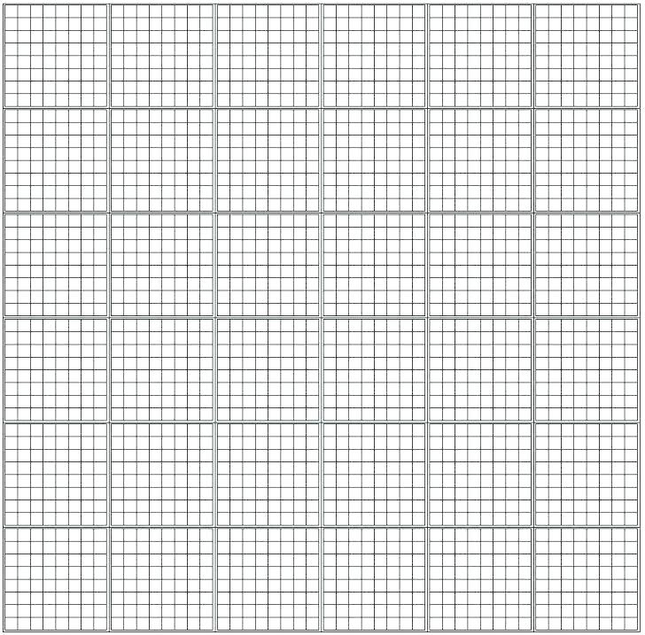

RECORD YOUR DATA

3) In the boxes below, record your time estimate of the first, second, third, and fourth contacts. These exact times are learned from your graph that you plot, and correspond to the moment when the line begins to change abruptly. If you do your graph properly, this will be obvious.

The time of contacts occurred at:

First contact hours

Second contact hours

Third contact hours

Fourth contact hours

4) From the graph, determine the elapsed time between the first contact and the second contact. This is the length ot time required for Charon to disappear behind the planet. This will lead to an estimate of the diameter of Charon. Record this time value in the box below.

The elapsed time between first and second contact was how many hours and minutes. Please express time in terms of hours and decimals instead of hours and minutes, ie.,
1.25 hours=1hour and 15 minutes,
1.50 hours=1hour and 30 minutes



5) From your graph, determine the time from the first contact until the third contact. This is the length of time required for Charon to traverse the diameter of Pluto. Record this value in the box below.

Calculate the elapsed time between first and third contact in hours and fraction of hours (minutes as decimals).

6) Repeat the step above for Charon to move from the third contact to the fourth contact. This is a second way to determine a time estimate involving the diameter of Charon. Record this value in the box below.

Calculate the elapsed time between third and fourth contact in hours and fraction of hours (minutes as decimals).

7) Repeat the above step for Charon to move from second to fourth contact. This will lead to a second estimate of Pluto's diameter. Record this value in the box below.

Calculate the elapsed time between second and fourth contact in hours and fraction of hours (minutes as decimals).

8) According to recent estimates, Charon has an orbital radius
Orbital_radius_{Charon}= 19,130km.
Assuming that this orbit is a circle, calculate the circumference( C) of Charon's orbit using the formula
C_{Charon} = 2⋅π⋅orbital_radius_{Charon}
Record this value in the box below.

The orbital circumference of Charon is
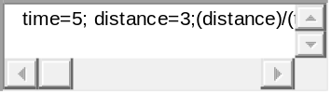km

9) It takes 6.387 days, or 153.3 hours for Charon to complete one orbit around Pluto. Assume again that the orbit of Charon is a circle, and calculate its orbital velocity. Remember, to determine this value,
velocity = distance /time
Record this value in the box below.

Assuming that the orbit of Charon is a circle, calculate Charon's orbital velocity:
km/sec

10. Multiply the orbital velocity of Charon by the elapsed time recorded in step 4. This will be your first estimate of the diameter of Charon. Record this value in the box below.

Your first calculated diameter of Charon is? km

In the text area below, please include all your calculations, how you arrived at your numbers by providing both the equations and numbers you used for step 10.
